**ASSIGNMENT-1**

|  |  |
| --- | --- |
| Date | 17-09-2022 |
| Team ID | PNT2022TMID24432 |
| Project Name | IOT BASED SMART CROP PROTECTION |
| Maximum Marks | 2 Marks |

**NAME:** SHAIK FARDEEN

**TOPIC :** Build a smart home using two sensors, led, buzzer in a circuit

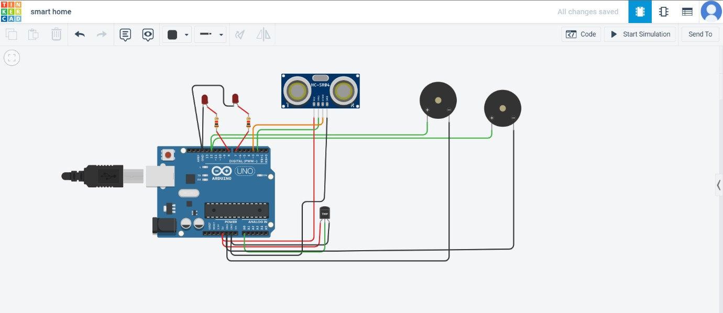

CODE:

int t=2; int e=3;

void setup()

{

Serial.begin(9600); pinMode(t,OUTPUT); pinMode(e,INPUT); pinMode(12,OUTPUT);

}

void loop()

{

//ultrasonic sensor digitalWrite(t,LOW); digitalWrite(t,HIGH); delayMicroseconds(10); digitalWrite(t,LOW);

float dur=pulseIn(e,HIGH); float dis=(dur*0.0343)/2; Serial.print("Distance is: "); Serial.println(dis);

//LED ON

if(dis>=100)

{

digitalWrite(8,HIGH); digitalWrite(7,HIGH);

}

//Buzzer For ultrasonic Sensor if(dis>=100)

{

for(int i=0; i<=30000; i=i+10)

{

tone(12,i); delay(1000); noTone(12); delay(1000);

}

}

//Temperate Sensor double a= analogRead(A0);

double t=(((a/1024)*5)-0.5)*100; Serial.print("Temp Value: "); Serial.println(t);

delay(1000);

//LED ON if(t>=100)

{

digitalWrite(8,HIGH); digitalWrite(7,HIGH);

}

//Buzzer for Temperature Sensor if(t>=100)

{

for(int i=0; i<=30000; i=i+10)

{

tone(12,i); delay(1000); noTone(12); delay(1000);

}

}

//LED OFF

if(t<100)

{

digitalWrite(8,LOW); digitalWrite(7,LOW);

}

}